Laboratory work №1
Use:
input(),
output(),
/ (division),
+ (sum),
– (subtraction),
// (quotient from division entirely),
* (multiplication),
** (exponentiation),
% (remainder of the division completely),
#(comments)

1. Sum of three numbers
Write a program that reads three numbers and displays their sum. Each number is written on a separate line.

2. Area of right triangle
Write a program that reads the lengths of two legs in a right triangle and displays its area. Each number is written on a separate line.
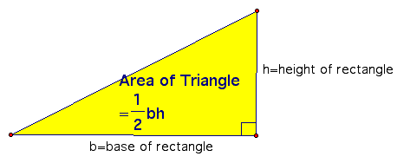

3. Apples division
n schoolchildren divide k apples equally, the non-fissile residue remains in the basket. How many apples will each student get? How many apples are left in the basket? The program receives the numbers n and k as input and must output the required number of apples (two numbers).

4. Electronic clock
Given the number n. Since the beginning of the day n minutes have passed. Determine how many hours and minutes the electronic clock will show at this moment. The program should print two numbers: the number of hours (from 0 to 23) and the number of minutes (from 0 to 59). Note that the number n may be greater than the number of minutes in a day.

5. "Hello, Harry!"
Write a program that greets the user by displaying the word Hello, the entered name and punctuation marks like in the example: “Hello, Harry!”

6. "Next and Previous"
Write a program that reads an integer and prints text similar to the example (spaces are important!).
1534 | The next number for the number 1534 is 1535.  The previous number for the number 1534 is 1533.

7. The school desk
The school decided to type three new math classes. Since they took math classes at the same time, it was decided to set aside an office for each class and buy new desks in them. At each desk can sit no more than two students. The number of students in each of the three classes is known. How much do you need to buy school desks so that they are enough for all students? The program receives three positive integers: the number of students in each of the three classes.

8."Shoelaces"
A shoe factory is about to start producing an elite shoe model. The holes for lacing will be arranged in two rows, the distance between the rows is a, and the distance between the holes in the row is b. The number of holes in each row is N. The lacing must occur in an elite manner “up, horizontally in another row, up, horizontally, etc.” (see figure). In addition, so that the laces can be tied with an elite bow, the length of the free end of the lace should be l. What should be the length of the lace for these shoes?
The program receives four positive integers a, b, l, and N as an input – in that order – and should output one number – the desired length of the lace.
